**Google Classroom Access Guide**

**Step One**

Your child has been given login details to access their Google Classroom account.

<http://classroom.google.com>

**Class :** 2Galaxy

**Name :** Nadia Perry   
**Email :** perrn004.307@sthprimary.co.uk  
**Password :** games8

**Step Two**

In the web browser tab, enter the web address <http://classroom.google.com>

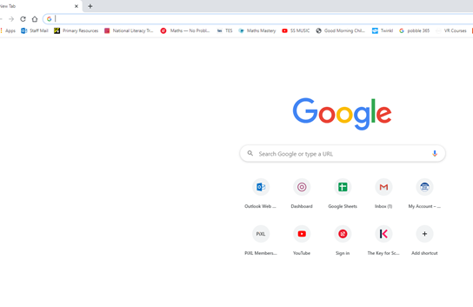

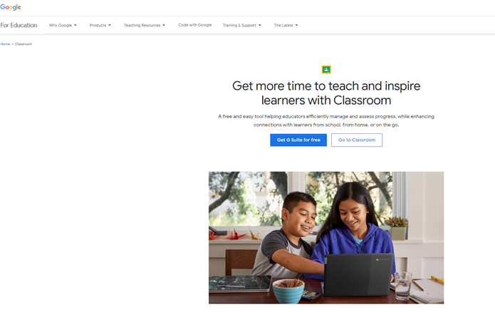

**Step Three**

Click on and enter the email address and password from the login card your child has been given.

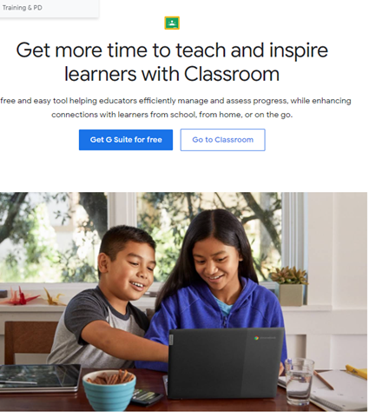

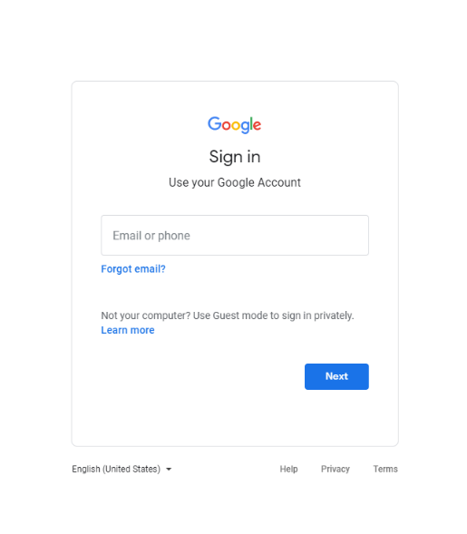

**Step Four**

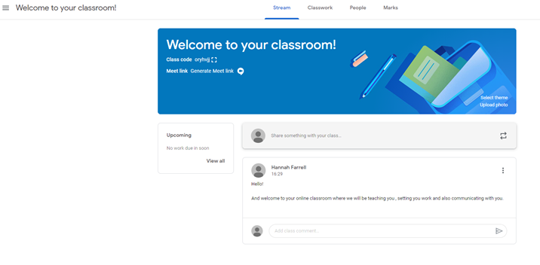

You have now gained access to the Google Classroom for your child!

Your class teacher will use the classroom to:

* Upload work for your child to complete. It will be marked and returned through the classroom.
* Send links to useful learning resources
* Share school messages
* Attend live teaching sessions using the meeting link provided.

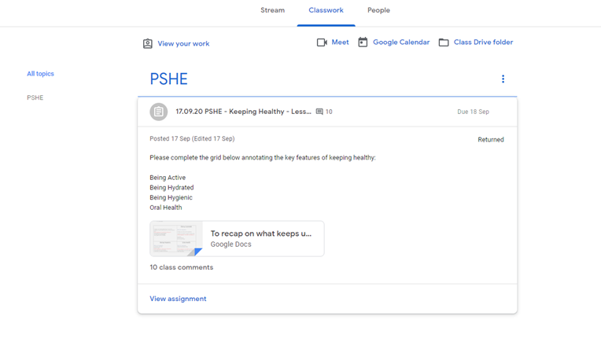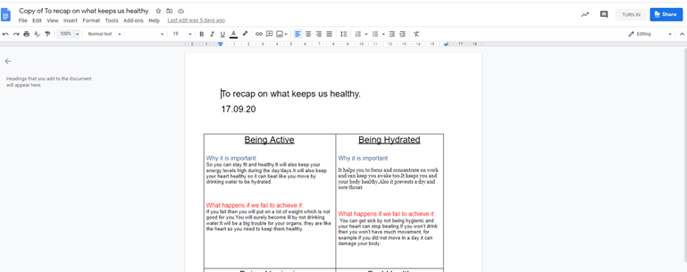

When delivering a **live lesson**, a link will be made available on the Google Classroom page for pupils to access. When attending a live teaching session, pupils must:

* Blank their screens
* Mute their microphones
* Follow teacher instructions during the live teaching
* Ask questions using the comments tool.
* Leave the meeting once the teacher has announced the live lesson is over.

If a parent has any questions about either Google Classroom or the learning in their child’s year group then can use the email below to contact the teachers:

One a piece of work is completed, the pupil needs to click on ‘***Turn In’*** so the work is sent to the teacher to mark. Once marked, the teacher will return it back to the pupil.

Class work

**Google Classroom Pupil Work**

Notifications of class activities will be visible on the Google Classroom main page. Pupils (or parents on behalf of younger pupils) can comment on this main page but they cannot post.