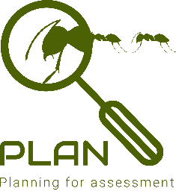 | Working scientifically skills  Year 1 & 2

Asking simple questions and recognising that they can be answered in different ways
- While exploring the world, the children develop their ability to ask questions (such as what something is, how things are similar and different, the ways things work, which alternative is better, how things change and how they happen). Where appropriate, they answer these questions.
- The children answer questions developed with the teacher often through a scenario.
- The children are involved in planning how to use resources provided to answer the questions using different types of enquiry, helping them to recognise that there are different ways in which questions can be answered.

Observing closely, using simple equipment
- Children explore the world around them. They make careful observations to support identification, comparison and noticing change. They use appropriate senses, aided by equipment such as magnifying glasses or digital microscopes, to make their observations.
- They begin to take measurements, initially by comparisons, then using non-standard units.

Performing simple tests
- The children use practical resources provided to gather evidence to answer questions generated by themselves or the teacher. They carry out: tests to classify; comparative tests; pattern seeking enquiries; and make observations over time.

Identifying and classifying
- Children use their observations and testing to compare objects, materials and living things. They sort and group these things, identifying their own criteria for sorting.
- They use simple secondary sources (such as identification sheets) to name living things. They describe the characteristics they used to identify a living thing.

Gathering and recording data to help in answering questions
- The children record their observations e.g. using photographs, videos, drawings, labelled diagrams or in writing.
- They record their measurements e.g. using prepared tables, pictograms, tally charts and bar charts.
- They classify using simple prepared tables and sorting rings.

Using their observations and ideas to suggest answers to questions
- Children use their experiences of the world around them to suggest appropriate answers to questions. They are supported to relate these to their evidence e.g. observations they have made, measurements they have taken or information they have gained from secondary sources.
- The children recognise ‘biggest and smallest’, ‘best and worst’ etc. from their data.

