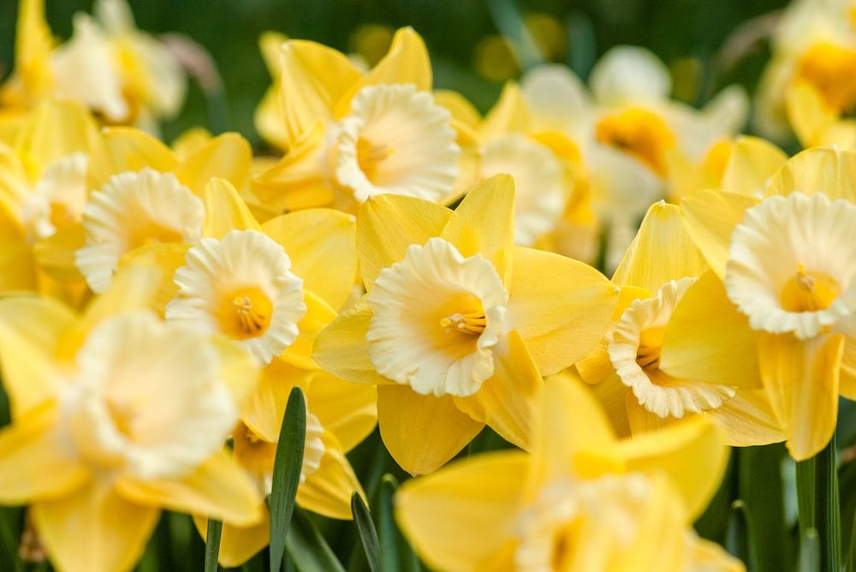

**Spring Term -F1**

**Lingham Primary School**



**PE**

**Communication and Langauge**

**Maths**

**English**



* Enjoy listening to stories and remember much of what happens.
* Understand some why questions.
* Begin to listen to others in a small group.
* Begin to join sentences with ‘and’.
* Recite numbers to 5.
* Begin to count up to sets of 5 objects.
* Join in with number rhymes and props to 5.
* Use fingers to represent numbers to 5.
* Number focus – 3, 4, 5.
* Talk about shapes.
* Talk about and continue ABAB patterns

Our key texts:

* I can Fly by Fifi Kuo
* Winter by Ailie Busby
* Winter is Here by Kevin Henkles
* Bear Snores On by Karma Wilson
* Busy Bear Cubs by John Schindel
* Dance
* Fundamental skills

**The Natural World**

**People, Culture and Communities**

**Past and Present**

**PSHE**





* Occupations: explore take on the role of a gardener/Site manager/Park keeper.
* Explore that there are different countries in the world – animals that live in hot/cold places.
* Seasons – Winter
* Ice – melting ice.
* Winter by Ailee Busbee.
* Snowy Animals – First Explorers
* Make sense of their own life history.
* Goals – what would you like to learn?
* Talk about feeling using words like happy and sad and begin to use other words.
* Settle to an activity of choice for some time.
* Play with one or more children.
* Begin to share and take turns with others.



**Spring Term – F1**

**Lingham Primary School**

**Being Imaginative and Expressive**

**Creating with Materials**

**Other bits & bobs**



* Begin to remember and sing entire songs.
* Play instruments with increasing control.
* Take part in simple pretend play.
* Begin to make imaginative small worlds.
* Create closed shapes to represent objects.
* Begin to draw with increasing detail.
* Begin to explore colour mixing.
* Begin to join different materials using PVA glue.
* PE is every Monday.
* Please return Library books on a Friday.
* Please remember to bring a water bottle every day.

