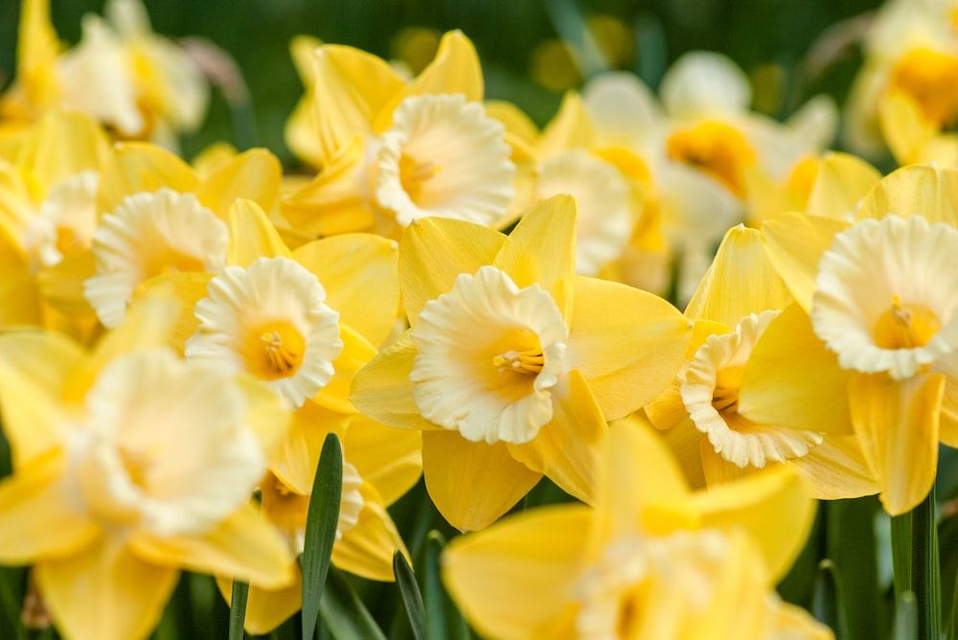

**Spring Term Year 1**

**Lingham Primary School**



**PE**

**Science**

**Maths**

**English**



* Exploring properties of materials
* Identify and name a variety of common animals-
* Carnivores, herbivores and omnivores
* Seasonal changes (Winter and Spring)
* Place Value to 20
* Addition and Subtraction to 20
* Place Value to 50
* Length and Height
* Mass and Volume

Our key texts:

* Where the Wild Things Are

Our writing genres:

* Setting description
* Story writing
* Poetry
* Dance
* Fundamental skills

**Art**

**DT**

**Geography**

**History**



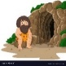

* Explore and evaluate a range of products with sliders and levers
* Explore and use levers and sliders
* Select and use tools, explaining their choice, to cut,shape and join paper and card
* To know what is meant by a significant person including an explorer
* To know who Christopher Columbus was and what he
* discovered
* To know why Neil Armstrong is a significant person
* To know the primary colours and how to mix secondary colours
* To explore colour through printing
* To use black and white to create a range of hues
* To experiment with pattern
* To explore the work of an artist
* UK Geography- To know key facts about the countries

in the UK

* To know the capital cities and the seas
* To know human and physical features of the UK



**Spring Term Year 1**

**Lingham Primary School**

**RE**

**Music**



**Other bits & bobs**

* Make movements to the pulse and tempo of a piece of music
* Use instruments to respond to the dynamics in a piece of music
* Create pitches and rhythms
* To develop knowledge of Christianity and stories from the bible
* To learn stories about Jesus and friendships
* To write a short prayer



* PE is every Thursday
* Please try your best to listen to your child read 3 times or more per week and sign the reading record
* There will be an opportunity for our year 1 children to showcase their work this term – letter to follow.
* Our year 1 trip will be to Chester Zoo- more details to follow



**Computing**



**PSHE**



* To understand that there are people in the community that help us to keep healthy
* To know my character strengths and know how to use my character to be at my best
* To know how to log on
* To debug algorithms
* Plan a pictorial story and understand the importance of sequencing
* To take clear photos
* To crop and resize a photo