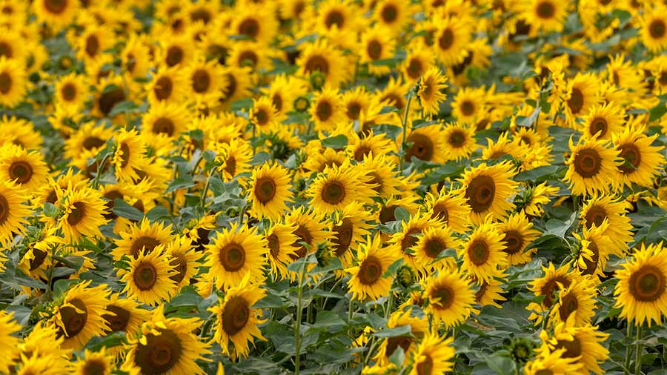

**Summer Term Year 3**

**Lingham Primary School**



**PE**

**Science**

**Maths**

**English**



* Measure, add, subtract and compare mass (g/kg) and capacity (ml/l)
* Add and subtract fractions
* Unit and non unit fractions
* Add and Subtract money
* Tell time to the nearest minute
* Calculate durations of time
* Measure and compare angles
* Parallel and perpendicular lines

Our key texts:

* Anthony Browne
* The Lion, The Witch and The Wardrobe (C S Lewis)
* Varjak Paw (S F Said)

Our writing genres:

* Recount (Letters based around Jemmy Button, Newspaper Reports based around Into the Forest)
* Lost Narrative
* Athletics (throwing, jumping, running for speed, running for distance)
* Food groups and Nutrition
* Types of skeleton
* The Human skeleton
* The role of muscles
* Parts of a flowering plant
* Photosynthesis
* Transpiration
* Pollination

**DT**

**Art**

**Geography**

**History**



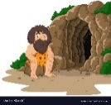

* Structures (Food packaging)
* Evaluate a range of existing products
* Design and make a product to fit a design brief
* Ancient Egyptian symbols
* Ancient Egyptian art forms
* Making papyrus
* Creating zines
* Climate zones and the reasons they are different
* Biomes and the vegetation found there
* Locations – continents, oceans and the UK

Ancient Egypt

* Ancient civilisations and dynasties
* The importance of the River Nile
* Egyptian achievements in agriculture, writing and religion



**Summer Term Year 2**

**Lingham Primary School**

**RE**

**Music**



**Other bits & bobs**

* Hinduism
* How can Brahman be everywhere and in everything?
* Would visiting the River Ganges feel special to a non-Hindu?
* Pentatonic melodies
* Singing and composing



School Trip:

Visit to Liverpool World Museum on **Wednesday 8th May**.

Please ensure children read at least 3 times per week and that this is recorded in their reading record.

Children should have their reading record and reading book in school each day.

Children can access TTRS through the links on Google Classroom and should play at least 3 times per week,



**Computing**



**PSHE**

* Citizenship
* Roles and responsibilities
* Recycling
* Charities
* Transitions
* Programming and debugging
* Scratch animations
* Online safety

